St Paul’s Academy, Finchale Road, Abbey Wood, SE2 9PX
November 2025
This statement details our school’s use of pupil premium funding to help improve the attainment of our disadvantaged pupils.
It outlines our pupil premium strategy, how we intend to spend the funding in this academic year and the outcomes for disadvantaged pupils last academic year.

School overview
Detail | Data
Number of pupils in school | 1119
Proportion (%) of pupil premium eligible pupils | 35.6%
Academic year/years that our current pupil premium strategy plan covers | 2023-2026
Date this statement was published | November 2025
Date on which it will be reviewed | Annual Review
Statement authorised by | Maggie Ryan
Pupil premium lead | Ananda Fernando (2023/2024)  Bronagh O’Neill (2024/2025)  Afolabi Joseph  (2025/2026)
Governor / Trustee lead | Bernard Borland CBE

Funding overview
Detail | Amount
Pupil premium funding allocation this academic year | £470,313
Pupil premium funding carried forward from previous years (enter £0 if not applicable) | £0
Total budget for this academic year  If your school is an academy in a trust that pools this funding, state the amount available to your school this academic year | £435,000

Part A: Pupil premium strategy plan

Statement of intent
The school motto ‘You are God’s work of art’ is at the heart of the mission of adults at St Paul’s. It is our desire that every child is heard, seen and loved. The restoration, formation and enhancement of a self-belief of ‘entitlement’ to the very best is reflected in the PP strategies / plans we put in place. The commitment to families expressed through governance and leadership in the school is one that focuses on securing excellent academic outcomes whilst providing formation which skills all students, but particularly those disadvantaged, for life. The Catholic ethos of the school also takes its lead from Catholic Social teaching which expressed a solidarity with the poor which is inspired by the Gospel. The principle of preferential option for the poor should ensure that decisions taken at all levels, allow appropriate mitigation and provision for those who are disadvantaged.
High quality teaching and a rich curriculum is key to the strategy at St Paul’s. The structural dismantling of the 2-year KS3, the introduction of CPD Wednesday and the introduction of Music as a weekly curriculum offer are just a few key aspects of this reform. The timetable bears little resemblance to the timetable 2 years ago. The EBACC offer is still strong. Double lessons, stable teaching staff in well-resourced rooms and high expectations for engagement and behaviour are securing lasting change in the day-to-day experience. The engagement in SSAT EFA is a commitment to the transformation of teaching practice to ensure that teachers know what their children know, act early to intervene and raise expectations for long term memory of the curriculum content.
The mental health, social and emotional support resources that we make available are significant and will provide practical support. Five learning mentors, two pastoral managers, Heads of Year supported by Deputy HOY, on site counsellor and multi-agency partnerships with Level X, XLP, RBG and many more indicate the dedication we have to support the wellbeing of pupils.
Targeted support for reading and access to language is a key principle of the strategy. Investing heavily in resources which will create a long-lasting change to the culture of reading will impact positively on PP students. Targeted intervention through the use of Lexonix and Hackney Lit reading, whole school reading cannon for Year 7-9 and the use of Bedrock Learning (initially for English as a trial and now rolling out across the subject areas) are core structures.
The Academy Personal Development Programme and Careers offer also prioritising support for PP students. Unifrog ensures that all students are supported with a career’s programme which keeps perspectives wide.
Chaplaincy and Safeguarding work underpin the support for those living in poverty. A deep, well-established connection to families is the goal for pastoral work. This allows us to work alongside them and work through challenges together. Students trust us to help them, that culture is absolutely crucial if we are to hear the voices of the disadvantaged. Student voice and leadership along with rewards is also a key strategy this academic year and beyond. Young people trained in debate (with targeted work for PP), student leadership roles and a culture of recognition and rewards ensures that school becomes a haven for our young people.

Challenges
This details the key challenges to achievement that we have identified among our disadvantaged pupils.
Challenge number | Detail of challenge
1 | Observations of data in Summer 2025 (PP): The data shows a significant attainment gap between disadvantaged pupils at the school and non-disadvantaged pupils locally and nationally.
2 | Observations (in class and from data) indicate that our students having lower than expected reading ages remains a significant barrier to them accessing to curriculum. The average reading and literacy age of incoming KS3 pupils is low, especially among those from disadvantaged backgrounds. Early baseline tests by our English teachers have found a discrepancy between disadvantaged pupils in comprehension tasks in comparison to their peers.
3 | Behaviour and aspirations:  Effective behaviour for learning and resilience in the face of challenges is a particular challenge for many of our pupil premium students. On average, our disadvantaged pupils are more likely to come from families who have had little experience of higher education. Consequently, going on to university-level study can be seen as an unrealistic goal for their secondary-level education. Pupils from disadvantaged backgrounds often need extra support to make them aware of their options for them following Year 11 or Year 13.
4 | Attendance:  Pupil Premium pupils show lower attendance, higher authorised and unauthorised absence, and higher lateness than their Non-Pupil Premium peers. This indicates a significant attendance and punctuality gap between the two groups.
5 | Home learning:  Our pupils from disadvantaged backgrounds often find it harder to complete their homework, due to less consistent home environments or a lack of engagement in school from their family. As the children grow older, the important of them keeping up with their homework becomes even greater, as they can fall behind their peers, leading to homework becoming a non-preferred task
6 | Cultural capital:  Many of our pupil premium students do not access cultural experiences or participate regularly in extra-curricular activities and some require places to study outside of school. This impacts upon their subject knowledge, resilience, confidence and character.

Intended outcomes
This explains the outcomes we are aiming for by the end of our current strategy plan, and how we will measure whether they have been achieved.
Intended outcome | Success criteria
Targeted Academic Support and High-Quality Teaching  Reduce the in-school variation between subjects for the outcomes of PP students | PP Overall in each subject area has little or no variation for P8 (or a replacement metric) for PP students compared to others.  All teachers in subject areas are able to use AFL, effective feedback strategies and targeted intervention to secure better outcomes for PP students to be more in line with non-PP
Targeted Academic Support  Embedding practice of PP students on reading recovery which leads to rapid improvement and supports reading comprehension at KS3 | All pupil premium students make demonstrable and externally verified progress in reading - towards their expected levels.  Pupils access curriculum content through texts/resources and are enabled to access homework because their reading ages support. The sensitivity and skill of staff is increased so that best practice with reciprocal reading practice which supports comprehension is established in all curriculum areas.  Activate staff through training and resources to ensure that students can read.  All adults in the school have keen awareness of the importance of reading and vocabulary. Some teachers take a lead role in mentoring students who have low reading ages.  PP Student engagement in Bedrock Learning is used to drive targeted intervention.  UPS teachers and volunteer teachers support the Hackney Lit reading programme with individual students.  Form time reading cannon which supports an ambitious reciprocal reading programme positively impacts on all learners.
High quality teaching  CPD leads to teachers delivering lessons which embed formative assessment, support long term and support high standards through self-regulation and teacher modelling. The use of data to ensure that impact is measurable is a key feature of leadership of learning | Curriculum mapping and planning ensure that all teachers can enact a curriculum which enables students to know more and remember more.  All teachers use AFL which ensures that gaps in learning and misconceptions are addressed immediately/and live.  Steplab coaching supports teachers in an individual way to make small incremental but impactful changes to their practice.  Developmental Drop Ins (DDIs) established to ensure that teachers are reflective practitioners and that any impact of low-quality teaching on PP is addressed in a timely way.  Extended leadership Training (Enrichment sessions for middle leaders (pastoral and academic) mean that strategies are data informed leaders and ensure they are empowered to be effective leaders of change. CPD Wednesdays have regular slots for development of and reflection on how to impact positively on Academic achievement of PP.  Provide funding for resources in the classroom and platforms that support memory and retention.  High expectations regarding exercise books and standards / routines for work.
Targeted Academic Support  Increase mentoring and coaching of low attainment/low engagement PP students to ensure that their attendance, ambition and career’s aspirations are raised. | Level X established across all Year groups to ensure that soft skills, opportunities and mentoring compensate for low self-esteem that can be associated with poverty.  Parental engagement and family support for attendance is robust and leads to changes in habits of engagement from families.  Teachers assigned some students to mentor with reading and with academic mentoring to support those PP students whose ACEs may pace them at higher risk
Targeted Academic Support  An ‘entitlement’ model offer for PP students is established which enhances cultural capital. | All clubs and enrichment activities evidence and evaluate impact on PP students.  A Cultural Capital strategy is developed as an ‘entitlement offer’ across the KS3 year groups by 2026.  Student voice informs us of the gaps for enrichment and CC trips/experiences.
Targeted Academic Support  SEMH support offer is one which is rich, varied and abundant in all areas of pastoral and school life. | All teachers understand the value of the modelled relationships and expectations of all students but particularly PP students.  Behaviour Curriculum ensures that the behaviour environment supports learning and access to the curriculum. Disruption or removal from lesson does not impact negatively on attainment and engagement of PP students.  Use student voice and surveys on a regular basis to find out more about the needs and experiences of PP students.  Level X engages with young people living with poverty and strategically involves them in enrichment after school and in the holidays. This gives inside information as to the challenges presented for young people in access to and engagement in education.
Wider Strategies  Reduce any additional stress experienced due to resource scarcity/hunger/lack of child care coverage in holidays. | Ensure breakfast for all allows all children breakfast and removes any stigma attached so that it increases PP.  Uniform Provision made and ‘preloved’ uniform culture is developed to support children.  Nil recourse families also included in this offer and those where families are close to but not meeting the threshold. An attitude of the whole school is disadvantaged given the local context. Increase the number of families accessing this  No PP child does not have access to a tablet or laptop at home and should not have to use a phone for homework.  Parental engagement through newsletters, rewards letters and phone calls for check-ins is an established practice.  Holiday clubs for sport and arts established in at least 3 half terms and a Summer School.

Activity in this academic year
This details how we intend to spend our pupil premium funding this academic year to address the challenges listed above.

Teaching (for example, CPD, recruitment and retention)
Budgeted cost: £270,000
Activity | Evidence that supports this approach | Challenge number(s) addressed
Consultant Support and SIP Partnerships | Practitioners with clarity about standards and expectations hold leaders to account and embed change. Full reviews and action plans ensure that strategic change is informed with evidence. | 1,2,3,4,5,6
Lead Practitioners and classroom support for TT | Areas where leadership focussed on formation of teachers, improving pastoral and classroom practice ensures a consistency of HIGH standards in key areas addressed | 1,2,5
Behaviour Support | 5 Learning Mentors  2 Pastoral managers  1 Seclusion Manager  2 days Counsellor on site (in addition to offsite with RBG provision we buy in) | 3, 4
UPS teachers and other senior staff as PP Champions | Engaging experienced staff in reading recovery and mentoring ensures that more PP students have access to mentors who monitor and enact the removal of barriers to learning. | 1,2,3,4,5,6
SSAT EFA Programme over two years programme | https://www.ssatuk.co.uk/cpd/teaching-andlearning/embedding-formative-assessment/funding/ | 1,2
Extended Leadership Training Programme | Leadership is second only to teaching and learning for impact on outcomes. The development of middle leadership is key because they are the watchmen. Subsidiarity comes into play here - the granular and local level of provision needs to be overseen by data informed strategy and leadership that has moral purpose to drive it | 1,2,3,4,5,6
Timetable Expert and design work | Timetables and how they structure learning and teaching can hugely transform a school culture and experiences day to day | 1,2
Additional Staff assigned to Attendance Strategies | Attendance is a key indicator and predictor of outcomes for academic success. Research indicates PP students are more likely to miss school and therefore lost learning becomes embedded. | 4

Targeted academic support (for example, tutoring, one-to-one support, structured interventions)
Budgeted cost: £90,000
Activity | Evidence that supports this approach | Challenge number(s) addressed
Level X | Impact measured termly - new programme and kept under review. Targeted and bespoke intervention means that it is tailored and responsive. Tackling wider and deeper issues than school behaviour systems and regular offers can attain. Recommendation from other local secondary school | 1,3,4
RAP Meetings | Data focussed interventions for PP after PPEs/Exams with core subjects and other curriculum areas on a weekly basis. | 1,2
Unifrog | https://edtechimpact.com/review/Y3VzdG9t ZXJTdXJ2ZXlSZXNwb25zZV91bmlmcm9nX2Fu Z2VsYV8yMDIxLTExLTE1VDE2OjQ5OjMyWg= =/ | 6
Bedrock Learning | https://www.teachwire.net/products/a-consistent-approach-to-vocabulary-teaching-with-instant-feedback-and-easy-to-measure-impact-discover-why-teachers-and-students-love-bedrock-learning/ | 1,2,5
Lexonix reading Programme and training | https://lexonik.co.uk/insights/lexonik-have-been-given-a-glowing-score-card-by-the-national-literacy-trust | 1,2,5
Reading Books from reading Cannon | https://educationendowmentfoundation.org.uk/projects-and-evaluation/projects/reciprocal-reading | 1,2

Wider strategies (for example, related to attendance, behaviour, wellbeing)
Budgeted cost: £70,000
Activity | Evidence that supports this approach | Challenge number(s) addressed
Enrichment: Duke of Edinburgh | https://www.dofe.org/impact-of-the-dofe/  Mentioned in OFSTED Framework Feedback. Students are already doing the award Value at Post 16 education | 6, 3
Free Breakfast (and other food where needed) | EEF - Review of evidence on free school breakfast provision  https://educationendowmentfoundation.org.uk/education-evidence/evidence-reviews/free-school-breakfast-provision | 1,2, 3,4
Uniform Provision | https://educationendowmentfoundation.org.uk/education-evidence/teaching-learning-toolkit/school-uniform | 1,2,3
Ensure IT equipment | https://educationendowmentfoundation.org.uk/education-evidence/guidance-reports/digital | 1,2,4
Debate Mate | EEF - Metacognition and self-regulation  https://educationendowmentfoundation.org.uk/education-evidence/teaching-learning-toolkit/metacognition-and-self-regulation | 1,2,6
Careers and Enrichment Lead and Hub base | https://www.careersandenterprise.co.uk/me dia/3ogdxqu1/bit67-cec-report_v3.pdf https://www.sec-ed.co.uk/content/best-prac tice/pupil-premium-raising-university-aspirations/  Part of the Gatsby Benchmarks and provision - need to ensure that all PP students access this fully as it is key strategy for Education and employment. | 6
Resources for Classroom | Gaps in learning through lost books; a lack of equipment is addressed through the introduction of folders, kits and revision resources. | 1,2,3

Total budgeted cost: £430,000

Part B: Review of the previous academic year

Outcomes for disadvantaged pupils
2025 Public Examination results of Disadvantaged Pupils along with Local and National Figures. 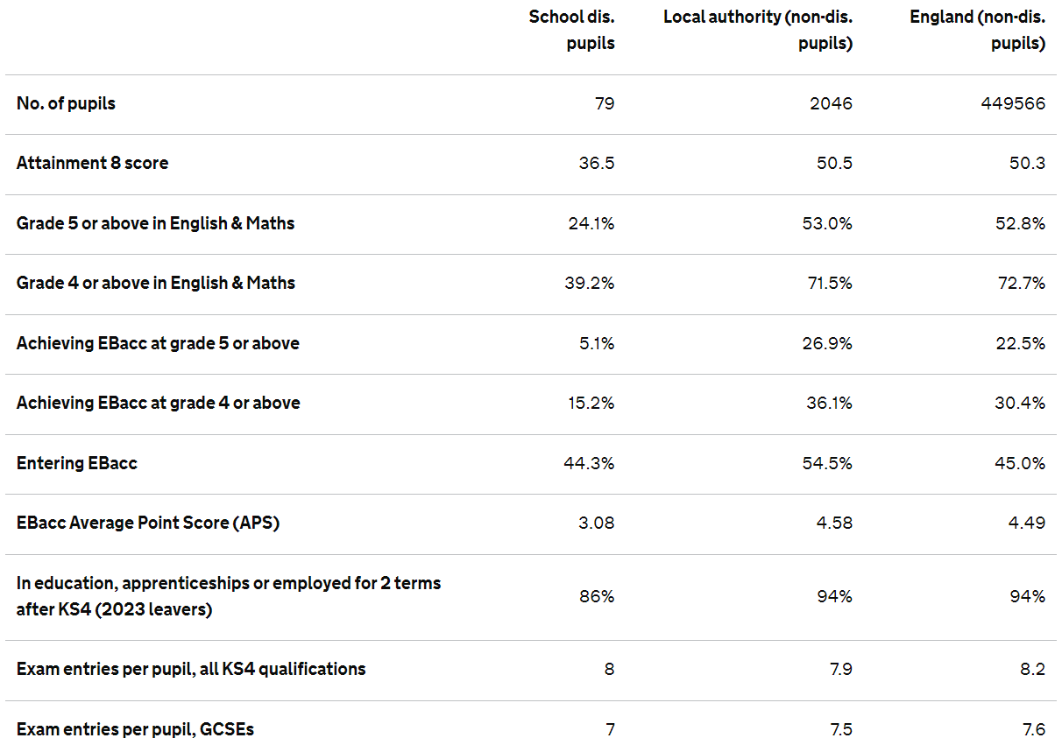

- Academic performance gap: disadvantaged pupils performed below both the local authority and national averages across nearly all attainment measures.
- EBacc results: the gap is significant for EBacc achievement at grade 4 and 5 and above
- Post-16 destinations: 86% continue in education, employment, or training. This is 8 percentage points below both the local and national rates.
- Curriculum breadth: exam entries are broadly similar to averages, suggesting that curriculum access is not the issue, rather, attainment is.
- Overall, the data shows a significant attainment gap between disadvantaged pupils at the school and non-disadvantaged pupils locally and nationally.

Whole School | Attendance Girls’ | Percentages

 | Attendances | Authorised Absences | Unauthorised Absences | Late Before | Late After
Pupil Premium | 86.98 | 7.52 | 5.50 | 7.99 | 0.34
Not Pupil Premium | 91.68 | 6.61 | 1.71 | 5.01 | 0.13

- Pupil Premium pupils have lower attendance (86.98%) compared with Non-Pupil Premium pupils (91.68%).
- Authorised absences are slightly higher for Pupil Premium pupils (7.52%) than for Non-Pupil Premium pupils (6.61%).
- Unauthorised absences are notably higher for Pupil Premium pupils (5.50%) than for Non-Pupil Premium pupils (1.71%).
- Pupil Premium pupils are late more often both before register (7.99%) compared with Non-Pupil Premium (5.01%) and after register (0.34% vs. 0.13%).

Whole School | Attendance Boys’ | Percentages

 | Attendances | Authorised Absences | Unauthorised Absences | Late Before | Late After
Pupil Premium | 89.56 | 6.74 | 3.70 | 6.18 | 0.23
Not Pupil Premium | 92.03 | 6.24 | 1.73 | 5.13 | 0.13

- Pupil Premium pupils have lower attendance (89.56%) compared with Non-Pupil Premium pupils (92.03%).
- Authorised absences are slightly higher for Pupil Premium pupils (6.74%) than for Non-Pupil Premium pupils (6.24%).
- Unauthorised absences are more than double for Pupil Premium pupils (3.70%) compared with Non-Pupil Premium pupils (1.73%).
- Pupil Premium pupils show higher lateness both before register (6.18%) compared with Non-Pupil Premium pupils (5.13%) and after register (0.23% vs. 0.13%).
Overall there has been significant change in school leadership including areas directly linked to the pupil premium strategy. New external leaders have been appointed and the academy has joined a trust to ensure the leadership rigour required to close the current gaps in outcome and attendance.

Externally provided programmes
Programme | Provider
NTP | Fleet Tutors
GLS Reading Scores Assessment | GL Assessment
White Rose | The White Rose Education
Language Nut | Global Digital Language learning Platform
Study Skills | Learning Performance
Cognitive Ability Test | GL Assessment

Further information
We are significantly transforming the day-to-day school culture to ensure that learning and progress is supported by strong positive learning behaviours underpinned by profound care in the hands of staff. We engage with School Improvement partners and school-to-school support to ensure that our leaders’ skills are enhanced and enriched, seeing best practice and developing a mindset of constant improvement.

