
St Paul’s Academy Provider Access Policy Statement 2024/25
Governors’ Policy Statement
Originator date: | Autumn 2024
Review date: | Autumn 2025
Provider Access Policy
Principal: Mrs S Ward
School Career Lead: Mr G Davis
Chair of Governors: Mrs S Griffin

VISION STATEMENT
At St. Paul’s Academy, our vision is to empower students, recognising each as God's work of art, to explore and excel in their educational journey. With an abundance of opportunities, we nurture ambition and strive for achievement, preparing students for both the world of work and future studies. Committed to academic rigor in every lesson, St. Paul’s is a place where talents are developed, new experiences are embraced, and the wonders of our world are discovered, ensuring that every student reaches their full potential.

St Paul’s Academy: Provider Access Policy
Introduction:
This policy statement sets out the school’s arrangements for managing the access of providers to the school for the purpose of giving them information about the provider’s education or training offer. This complies with the school’s legal obligations under Section 42B of the Education Act 1997.
St Paul’s Academy is committed to ensuring there is an opportunity for a range of education and training providers to access students, for the purpose of informing them about approved technical education qualifications and apprenticeships. St Paul’s Academy is fully aware of the responsibility to set students on the path that will secure the best outcome which will enable them to progress in education and work and give employers the highly skilled people they need. That means acting impartially, in line with the statutory duty, and not showing bias towards any route, be that academic or technical.
St Paul’s Academy endeavours to ensure that all students are aware of all routes to higher skills and are able to access information on technical options and apprenticeships (The Department of Education, July 2021: “Baker Clause”: supporting students to understand the full range of education and training options, and the Provider Access Legislation, January 2023).
Aims:
The St Paul’s Academy policy for Access to other education and training providers has the following aims:
- To develop the knowledge and awareness of our students of all career pathways available to them, including technical qualifications and apprenticeships.
- To support young people to be able to learn more about opportunities for education and training outside of school before making crucial choices about their future options.
- To reduce drop out from courses and avoid the risk of students becoming NEET (Young people not in education, employment or training).
Student entitlement:
St Paul’s Academy is fully committed to meeting the statutory requirement for students to have direct access to further education, technical training, and apprenticeship providers. The complete programme, detailing the curriculum for all year groups, is available on the school’s website. In compliance with the new legal mandate, the school will offer at least four encounters with providers of approved technical education qualifications or apprenticeships. These encounters will take place during assemblies throughout the year, in addition to providers participating in school career events. As St Paul’s Academy serves students from Years 7 to 11, these opportunities will be tailored accordingly.
All students in Year 8 – 11 at St Paul’s Academy are entitled to:
- To explore technical education qualifications and apprenticeship opportunities as part of a comprehensive careers program, offering information on the full spectrum of education and training options at every transition point.
- To engage with local providers and learn about the opportunities they offer, including technical education and apprenticeships, through events such as options evenings, assemblies, group discussions, and taster sessions.
- To gain a clear understanding of how to apply for a wide range of academic and technical courses.
For students of compulsory school age, these encounters are mandatory. There will be at least two encounters during the ‘first key phase’ (Years 8 and 9) and two more during the ‘second key phase’ (Years 10 and 11).
These provider encounters will be scheduled during regular school hours, ensuring that each provider has sufficient time to:
- Present information about their organization and the approved technical education qualifications and apprenticeships they offer
- Outline the potential career paths associated with these options
- Provide insights into the learning or training experience with their institution, including opportunities to meet staff and current students
- Answer any questions students may have.
Meaningful provider encounters:

One encounter is defined as one meeting/session between pupils and one provider. We are committed to providing meaningful encounters to all pupils using the Making it meaningful checklist.

Meaningful online engagement is also an option, and we are open to providers that are able to provide live online engagement with our pupils.
Considering the needs of all pupils:
St Paul’s Academy is fully committed to ensuring that all pupils have equal access to meaningful provider encounters. We recognise that some students, including those with special educational needs and disabilities, looked-after children, and pupils from Gypsy, Roma, and Traveller backgrounds, may require additional support to fully benefit from these opportunities.
To address this, St Paul’s Academy will work closely with the local Careers Hub to identify appropriate providers for these encounters. We will also engage with parents/carers, the Special Educational Needs Coordinator (SENCO), and other relevant staff to identify any barriers and necessary support, ensuring that each provider encounter is tailored to meet the specific needs of every student.
Previous providers:

Providers who have been invited into St Paul’s Academy to date include:

- Shooters Hill Sixth Form College
- London South-East Colleges
- The Halley Academy
- Leigh Academy Stationers
- Christ The King Sixth Form College (St Mary’s and Emmanuel)
- London Design and Engineering
- The Leigh UTC
- East London Arts and Music
- North Kent College

*Providers in bold and underlined offer technical education or apprenticeships

Destinations of St Paul’s Academy students:

Last year (2023) our year 11 students moved on to a range of providers in our local area in Greenwich:

- Christ The Sixth Form College St Mary’s
- Christ The Sixth Form College Emmanuel
- Colfe’s Independent School
- Shooters Hill Sixth Form College
- London South East Colleges
- Stationers Crown Wood Academy
- North Kent College
- Thomas Tallis
- Beths Grammar
- Bexley College
- Bromley Football Club
- Eltham Hill for Girls
- Brampton Manor
- Woolwich Poly
- Bexleyheath Academy
- City of Westminster
- Harris Garrard
- Elam
- Wilmington Grammar
- Langley School for Girls
- Townley Grammar
- Ravensbourne College
- Harris Greenwich
- Newham College
- Charlton Athletic
- City and Islington College
- Plumstead Manor
- Hallie Academy
- Beths Grammar
- Welling
- Harris Falconwood
- Hadlow College
- Tower Hamlets
- Bromley College
- Lewisham College
- Chis & Sid Grammar School

Opportunities for access:

The school provides the four legally required provider encounters (highlighted in bold below) as well as additional events integrated into our careers program. We welcome providers to visit the school and speak with students or their parents and carers. Please contact our Careers Leader to discuss the most suitable opportunity for your involvement.

Draft Careers Education and Guidance Programme 2024-25

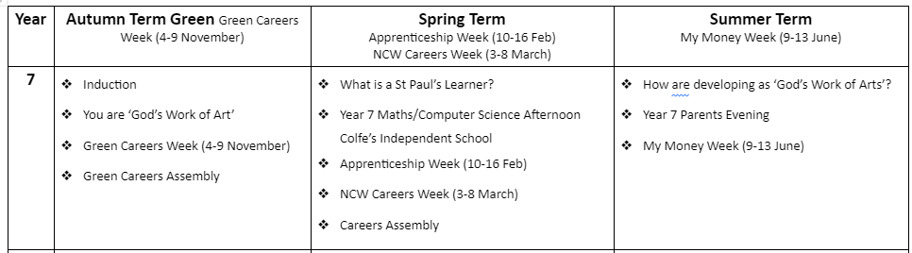
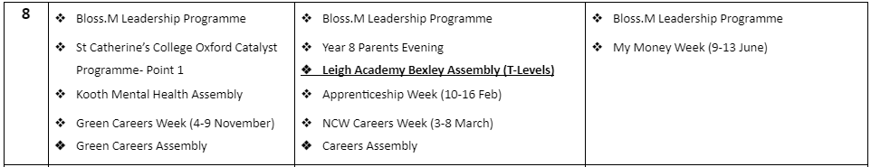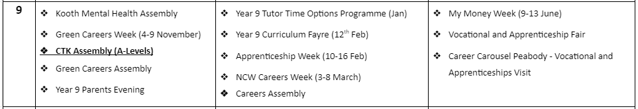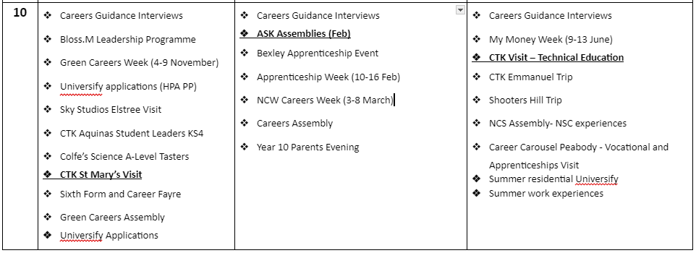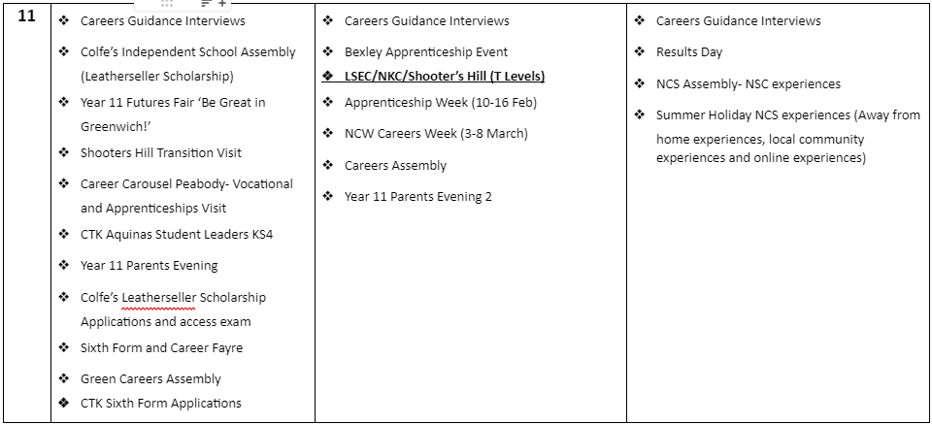

*Providers/Activities in bold offer information on technical education or apprenticeships

Granting and refusing access:

The school will accommodate any reasonable request from external providers to speak with students. However, the school reserves the right to deny access if there are safeguarding concerns or if the request is deemed unreasonable.

Safeguarding:

Our Safeguarding Policy details the procedures for verifying the identity and suitability of visitors. Education and training providers must adhere to this policy. Upon arrival at the school, you will receive a leaflet outlining our expectations for visitors. Copies of the Safeguarding Policy are available on our website.

Development:
This policy is developed and reviewed annually by the Careers Leader and Line Manager, Michelle Hepburn, in accordance with the latest best practice guidelines from the Department for Education.
Links with other policies:

It is supported by and aligns with key school policies, including those on Careers, Safeguarding, Equality and Diversity, and Special Educational Needs and Disabilities (SEND).

Equality and Diversity:

Access to external providers is actively promoted to ensure that all students can obtain information about further education and apprenticeship opportunities. St Paul’s Academy is dedicated to helping students make informed decisions about their futures based on impartial information.

Requests for access:

Requests for access should be directed to Gordon Davis, Careers Leader. He can be reached by telephone at 0208 311 3868 ext. 194 or by email at gordon.davis@stpauls.greenwich.sch.uk.

Grounds for granting requests for access:

Providers will be granted access to speak during school assemblies, scheduled Careers lessons, and any Careers events organized by St Paul’s Academy. Additionally, students may have the opportunity to visit other providers as part of trips arranged in partnership with the school.

Details of premises or facilities to be provided to a person who is given access:

St Paul’s Academy will provide a suitable room or assembly hall as agreed with the provider. All rooms are equipped with computers, projectors, and screens, and computer labs can also be arranged if needed. The Careers Leader or Careers Adviser will coordinate with the provider to ensure that the facilities meet the needs of the audience. Appropriate safeguarding measures, including DBS checks, will be conducted if students are left alone with providers. A member of the Careers Team will meet and supervise the providers, facilitating the session.

Live/Virtual encounters:

St Paul’s Academy will accommodate requests for live online encounters with providers, which can be streamed into classrooms or the school assembly hall. To ensure a smooth experience, technology checks will be conducted in advance to confirm system compatibility.

Complaints:

Any concerns regarding provider access can be addressed through the school’s complaints procedure or by contacting The Careers & Enterprise Company directly at provideraccess@careersandenterprise.co.uk.

Parents and Carers:

We encourage parental involvement, and parents may be invited to attend events to meet the providers. Parental engagement is particularly encouraged for career guidance for students with SEND needs or EHC plans, which can take place from Year 9 onwards. Parents and carers can access information on pathways and career opportunities on the school website.

